(Approx. 1,397 words)

2007 Chaos, What/Who Wins in 2008?
By Andy Marken, Marken Communicaitons
www.markencom.com
andy(at)markencom.com

Obtained from APCUG with the author's permission for publication by APCUG member groups.


The fun of analyzing the past 12 months is…it’s easy!

But forecasting 2008 requires separating dreams from reality…early adopters from mass market.

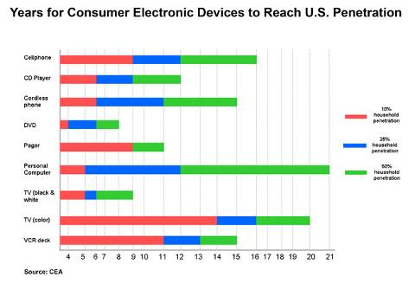
For the early adopters the home entertainment network is here.

The converged mobile content/communications device is here.

Content when you want it, where you want it, how you want it is here.

For the mass market…it’s an awkward transitional period.

2007’s Time Magazine’s Person of the year was … You.

The yous of the world are connected and have the choice of an almost limitless variety of online content – written, photo, music, video.


Personal content is gaining momentum. The long tail of entertainment is moving more rapidly than Chris Anderson envisioned when he wrote his first book.

The entertainment shift is making micromarket segmentation more important to manufacturers and suppliers.

Consumer advocacy/protection groups historically viewed Microsoft as the big evil one located in Redmond, WA but with tentacles around the globe. Ironically, we don’t view the kind, fun-loving kids of Google in the same manner even though they touch almost everyone on the earth in one way or another multiple times…every day.

They’ve helped us get over concerns of privacy. In just a few minutes you can find out almost anything/everything you want to know about any company, any individual. Get over it !

To help even more they are going to make a move to build out the communications infrastructure and they’ll begin offering location tracking “services” all just to help…you!

But how can you consider any of the Googlites activities/efforts could ever be used for evil when they have vowed they will do everything in their power to regreen the planet?

Jostling for Their Futures

While mobile device convergence got off to a rocky start this past year as bandwidth providers, content owners, portal services and manufacturers tried to determine exactly how they were going to get their unfair share of the consumer’s dollar.

This could be a long, bloody battle because it will determine the shape and future for each segment well into the 22nd century.

The initial devices in an awkward manner let you use them to place/receive calls, watch TV/video, listen to music, track your location and handle your IM/email communications they moving target first generation products. We will see three to four generations of new products in 2008 as producers focus on key issues:

- Significant improvements in ease of use
- Fexibility in allowing users to customize applications to suit themselves
- Managing the bloating storage issues

With the explosion of content on the iNet we’re seeing a dramatic increase in the demand for higher bandwidth.

Legacy applications like email and simple web browsing required relatively little bandwidth.

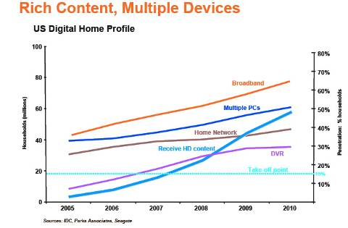
The three-minute call was easily handled by landline and thru-the-air phone services. But add the expectations of flawless HighDef and future Ultra HD content and video on demand and we will be faced with two options that only the bandwidth providers want to consider:

- Dramatic investment in bandwidth infrastructure (higher rates to pay for the expansion)
- Tiered services and payment schemes to support managed QoS service provisions
- Year of Storage

Because of the glut and demand for content, Time Magazine’s person of the year for 2008 will undoubtedly be…Storage !

Storage for the home.
Storage for the mobile device.
Storage for the personal stuff.

While everyone still has closets, drawers, storage sites stashed with dusty analog content; the cost and work of bringing it into the digital era is more than anyone wants to contemplate.
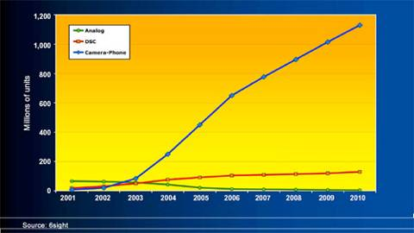

But today’s stuff is a different matter!

The new product, new technology buzz of solutions for the home is just beginning this year and it will have a ways to go before it reaches mass market. A few manufacturers like HP are delivering first generation home network storage solutions that kinda work with and for the customer rather than in their own engineered manner.

True, you can:

- Network them
- Move content from one system to another
- Back up the stuff locally and remotely

But none of it is yet easy, natural which is required for mass market implementation. The industry over the next several years will be focusing on:

- Increasingly delivering on the promises of UPnP
- Providing self-diagnostic, self-healing storage devices
- Delivering more intelligence on deterring when content needs to be moved from one system to the home storage device and when the content needs to be archived/protected offsite

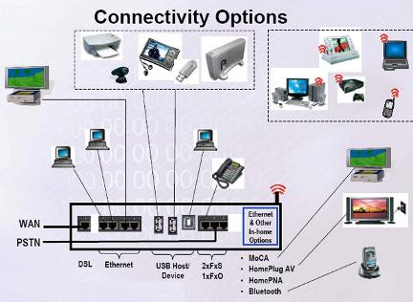
That’s a heavy workload and will still require evolutionary consumer adoption until we reach a point where use is just too easy, too logical, too economic not to use.

In the meantime, 2008 - 2010 will be a great period for storage device, media, solution providers – hard drive, flash, optical.

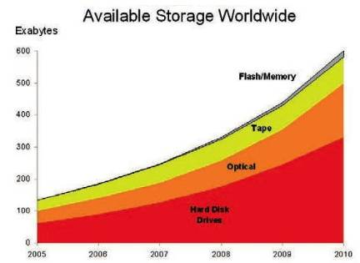
People will still be comfortable in storing and sharing digital files on blank media. CD media sales have been flat to slightly down this past year. DVD media sales have probably reached their peak. Once we see more BD/HD DVD burners hit homes/offices we’ll see the recordable media format sales increase because it is a logical extension, an evolutionary step in storage for consumers.

A DVD burner – which stores content on both CD and DVD – lasts five plus years before it needs to be replaced. That replacement price today is well under $50 today. The media costs virtually nothing. People “know” their content is archived.

While the save-and-sneakernet product market will remain stable, the hard drive/flash market will grow significantly this coming year.

Home Storage

By the end of 2008, 1TB/2TB home servers will become normal.

250GB storage in notebook and desktop systems will become standard.

80GB mobile devices will be “expected” as we use them to carry our music, photos, video, web shows, TV fare.

The biggest winner in this HD space will be the one who does more than just offers higher capacity, cheaper bit buckets.

The edge will go to the producer who can deliver diagnostic and health maintenance intelligence, not the one who can simply squeeze more data on a single platter.

Mobile Play

Flash technology which is working to find a home in lighter, more power efficient notebooks will be a niche solution in 2008. Advertised and wished for performance probably won’t be achieved for 2-3 technology generations. Even with the early adopters SSD units in notebooks will be a “bragging rights” niche product until at least 2009.

But there is still an almost insatiable demand for flash based solutions.

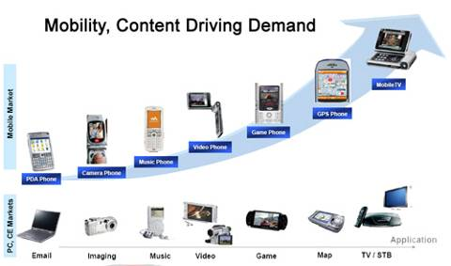
In the coming year, “everyone” will have a couple of 8-12GB USB drives, 4-5 8-16 SD cards for their cameras, a couple of 16-24GB cards for their camcorder and 3-4 4-8GB cards for their cellphone.

Of all of the storage applications, we believe the mobile phone usage will be the most exciting and the most aggressive.

Now that the cellular services of Americas have come to realize they are service providers, not device sellers we should see a rapid succession of new mobile phones both here and abroad that will make life on-the-go easier and more satisfying.

It’s also more logical for the phone producers.

If you scan the BOM (bill of materials) of a 4GB cellphone with 5MP camera and 2-3 in screen, one of the most expensive components has got to be …storage.

Remove storage from the equation, offering the consumer with “virtual storage” options and other software-ready features like music/video download, GPS, 3D screen and suddenly you have an economic device you can enjoy for years…yeah right!

Handset manufacturers will be delivering a more feature-rich, more economic and more flexible device to the manufacturer and will place the onus to deliver low-cost, rugged capacity where it belongs…at the flash producers’ front door.

At home and away the demand is going to be connected to/using your content in new and different ways. Simplifying the process and making it cheaper, more reliable, more flexible is going to make it easier to kiss fixed providers goodbye …like the cable guy!

This article has been provided to APCUG by the author solely for publication by APCUG member groups. All other uses require the permission of the author (see e-mail address above).

